We are

VibrantSTRONG
ANNUAL COMMUNITY REPORT
April 1, 2019 - March 31, 2020

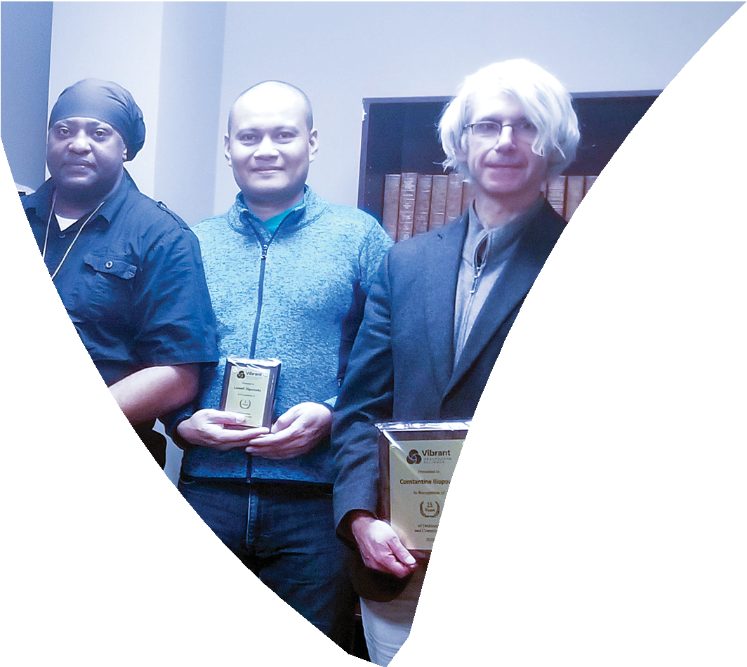
ABOUT VIBRANT
Vibrant Healthcare Alliance was formed with the commitment to create a dynamic and more client-centric approach to enhancing the quality of life and health out comes of individuals living in the Greater Toronto Area, particularly vulnerable individuals with complex needs.
OUR TEAM

Doctors | 5
Nurse Practitioners and Nurses | 6
Allied Health Professionals | 7
Personal Support Workers | 98
Clinical and Admin Support Staff | 6
Other staff including directors, admin | 22
Volunteers and students | 140

OUR VISION
Empowering independence, health and well-being together.

OUR MISSION
Building healthier communities using integrated services to empower individuals living with complex issues.

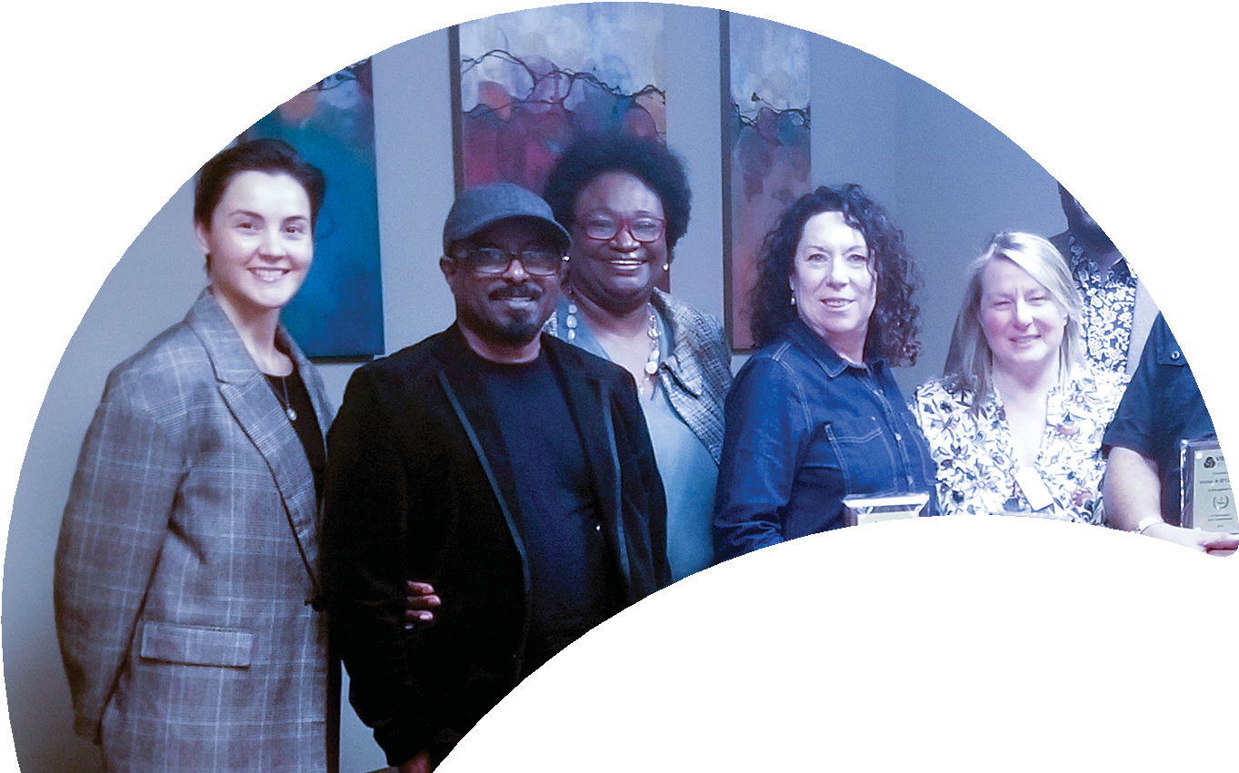
OUR VALUES
Inclusiveness Excellence Accountability Collaboration

The last year was incredibly exciting, tremendously successful and filled with significant milestones which we are privileged to highlight throughout this community report.
BOARD CHAIR & CEO MESSAGE
First and foremost, all of our activities centered around our key strategic priority, putting clients first. The people we serve are our number one
priority and at the core of everything that we do.

While the world today looks and feels vastly different than it did just a few short months ago, here are some of our 2019/2020 highlights: Achieved full accreditation status
Confirmed as a member of the North Toronto – Ontario Health Team Consolidated our internal work towards an innovative, integrated service delivery approach.

While we have made significant strides towards facilitating a more integrated health system and supporting our clients, none this would be possible without the dedication of our staff team.

We are extremely proud of the dynamic, front-line staff team at Vibrant and appreciate their continued commitment, compassion, and hard work in providing excellent care to the vulnerable clients and communities we serve.

Carla Palmer Simone Atungo
Chair, Board of Directors Chief Executive Officer

CLIENT VOICES
Client voices are the heart of our work.
We learn vital lessons about what’s important to them. In turn, they help us better understand their choices, their needs and their experiences.

Meet Adam Cohoon

"I very much enjoyed many programs including the meal program that brings hot and nutritious meals to my apartment twice a week. I also enjoy the online yoga and stretching program. Lucy’s GROOVEs program is a 90-minute check in on how you’re doing during the pandemic which has been a great help. Having telephone counselling has also supported me through this time."

Meet Errol Wilson

"I’ve been a client of Vibrant for about five years and I like it because I can access all my services under one umbrella. I even get cooked meals twice a week and they are delivered to me, so it is very accessible and convenient. I have also gotten wellness packages to help supplement my groceries.
I think that the programs are very handy overall."

YEAR IN REVIEW

VIBRANT ACHIEVES
FULL ACCREDITATION STATUS

In November 2019, Vibrant participated and successfully passed a comprehensive accreditation review process conducted
by the Canadian Centre for Accreditation (CCA).

INTERNAL ALIGNMENT OF SERVICE DELIVERY MODELS

This year, Vibrant set out to build inter- nal alignment, optimize the delivery of client services and facilitate a culture of continuous quality improvement.
Four (4) guiding principles were successfully introduced:
- Adopting a mindset of innovation and learning.
- Taking risks in trying out new ap- proaches while refining them over time.
- Being flexible and willing to change how we currently work to be as inte- grated as possible.
- Openly sharing, learning, and build- ing on our successes and failures in a safe environment to promote continu- ous quality improvement.

FOCUS ON STRATEGIC PARTNERSHIPS

In 2019, Ontario Health Teams were introduced as a new way of organizing and delivering health care to clients in their local communities.
When Vibrant was confirmed as a member of the North Toronto – Ontario Health Team, they worked closely with clients, caregivers, and local health partners to ensure better access to care for vulnerable clients with complex needs.

Visit vibrantannualreport.ca
to read full stories.

16,289
client days

118,151
service hours

CARE NUMBERS

1,778
primary health care clients served

11,716
group attendance

13,902
client provider interactions

76
outreach activities
836
health promotion
group sessions

45
supportive housing clients

3,804 Active clients including:

402
clients living with
physical disabilities

1,389
youth with
complex needs

1,564
older adults 55+
with complex needs

OVERALL CLIENT EXPERIENCE:
I always feel comfortable and welcome | 88%
I am treated with dignity and respect. | 90%
Staff demonstrate an understanding of client needs | 86%
I trust staff to keep my personal information confidential. | 86%
I receive services when I need them | 82%
My expectations for service and quality are met | 86%
Helps me improve my health and well-being | 87%
I know how to make a suggestion or complaint | 82%
Helps me connect to services and programs in my community | 79%
I can get an appointment on the date I want | 76%
Accessible for people living with physical disabilities | 88%
I am satisfied with the services I receive | 88%
Integration has been positive on program and services | 66%
I would recommend them to my friends and family | 87%

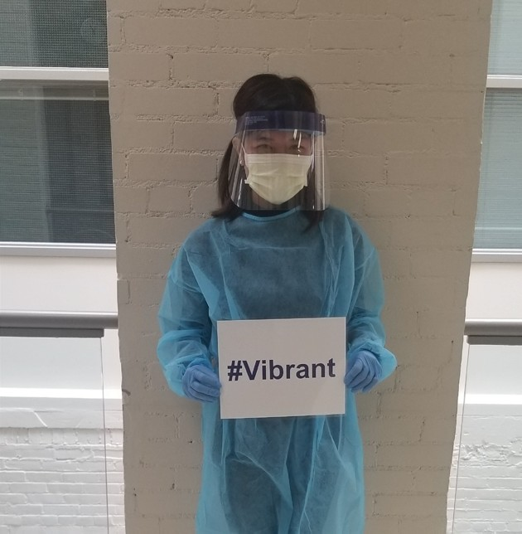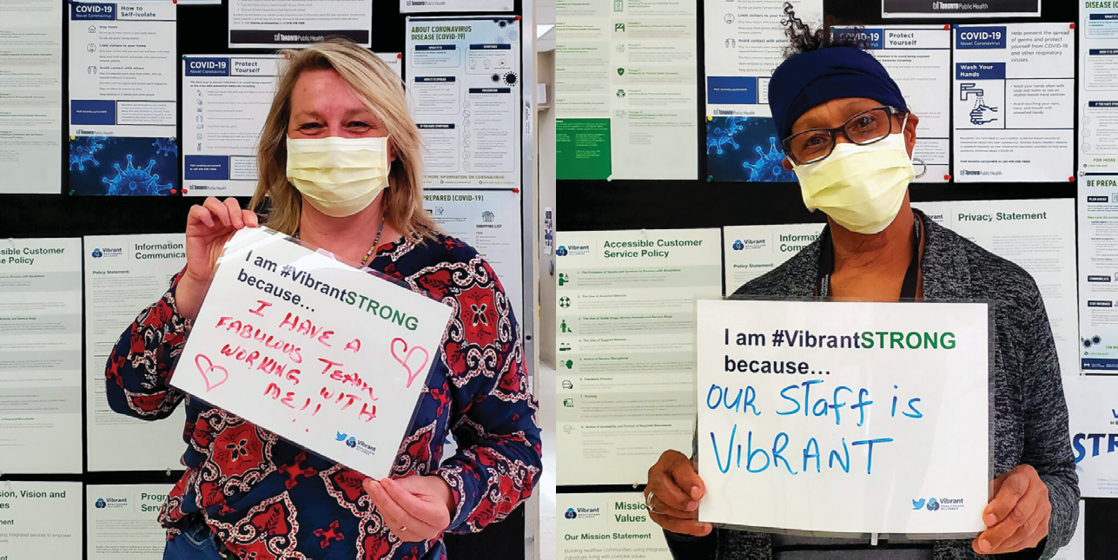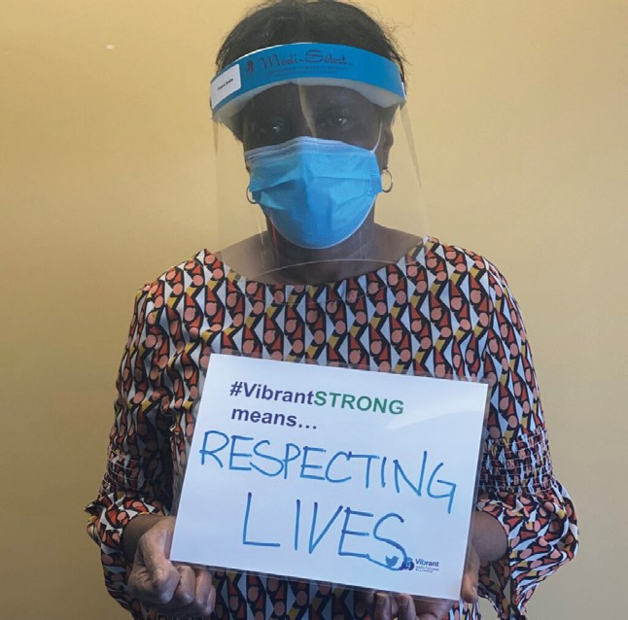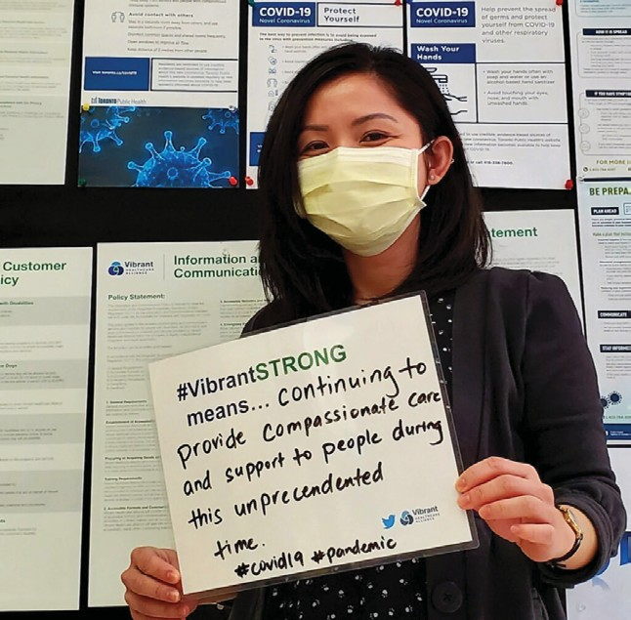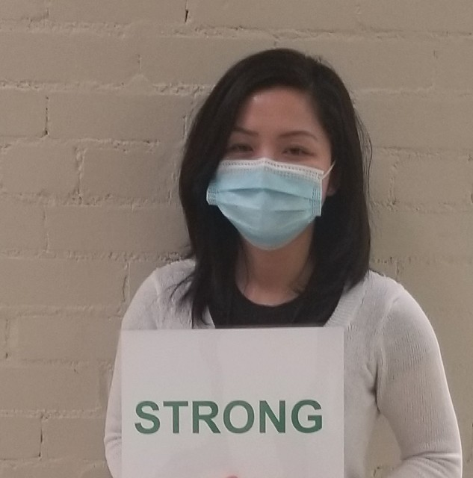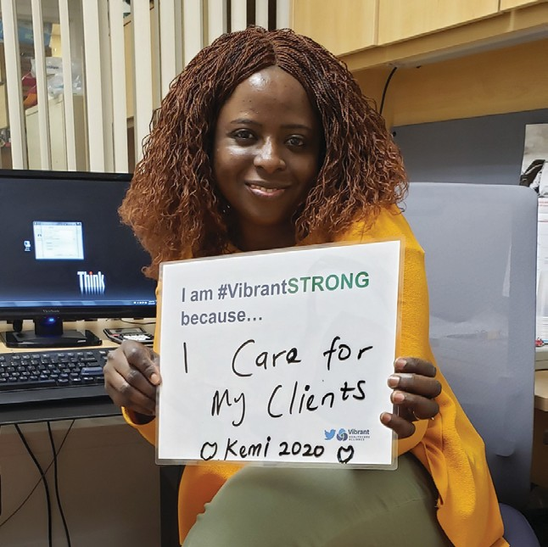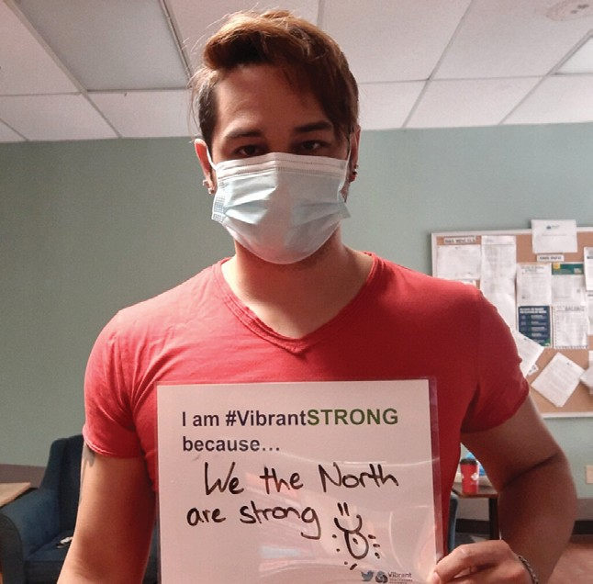

FINANCIALS

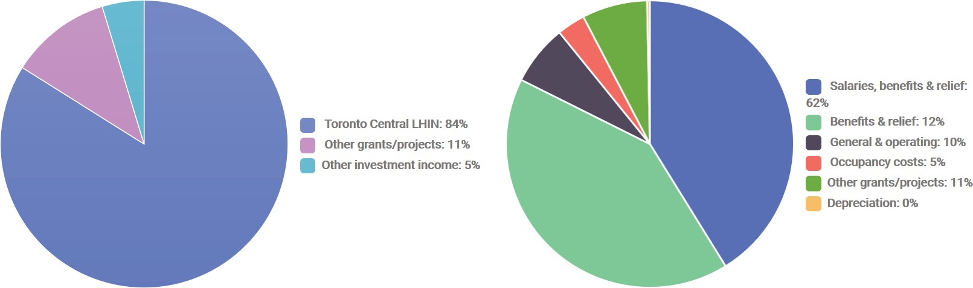

The Board of Directors would like to acknowledge and thank our funders, program partners, donors, volunteers, staff and clients for their amazing contributions this past year.

Dear team:

"To the world you may be one person, but to one person you may be the world." – Unknown
Thank you for being the eyes, the ears, the hands, and the voice
of one of the most vulnerable communities within our society. Thank you for opening your hearts up to the concerns and challenges that families share. Thank you being there when the days were long, and the rewards were hard to see. Thank you for treating those in your care as a mother, a father,
a best friend - not just as a case file. Thank you for tending to those small details that make the biggest difference. Thank you for putting a smile on the faces of those you help each day.
We see you.
We support you.
We thank you for being VibrantSTRONG.

OUR LOCATIONS:
Head Office
Anne Johnston Site 2398 Yonge Street Toronto, ON M4P 2H4
Coxwell Site
611-695 Coxwell Avenue Toronto, ON M4C 5R6

Carlton Site
84 Carlton Street, Main Floor Toronto, ON M5B 2P4

Jarvis Site
460 Jarvis Street, 4th floor Toronto, ON M4Y 2X8

vibranthealthcare.ca 416.486.8666

